SIM SHEET

both based on coasts near big states with riches

scandinavia and northern european islands

mediterranean litoral

tech crucial

viking tech

Ships and sailing gear have been excavated and replicas made from them for testing in practice, showing the seaworthiness of the Norse ships, as well as their speed and efficiency. (viking navigation in oxford encyclopedia of maritime history)

fast pirate ships

oxford encyclopedia of maritime history

piracy

 A piracy cycle has been proposed for these communities, suggesting that they start out as small independent groups who begin to flourish with the rise of local trade and who then capture bigger ships and organize into local bands that transmute into larger fleets before becoming a power in their own right. The Cilicians of Anatolia are a classic case of this. They went right through the cycle in the first century b.c.e. and established a dominant naval presence in the Mediterranean.

In some areas such as northern Europe persistent local piracy was the norm. The Vikings were an exception, as they roamed and raided at will until the small medieval governments could rally against them—as the French and English finally did—and as their own land hunger started to make them settlers rather than raiders. After the Vikings, local adventurers took over once again with petty raiding.

oxford encyclopedia of maritime history

piracy

also with cilicia -- impossible to totally stamp out piracy; emerged again especially in 230 as the Roman navy was under full decline

116 SSD

"Omerod suggests that Rome's negligence in controlling the pirates, especially those of Cilicia, was deliberate, motivated by the growing demand for slaves in the still expanding latifundia. Only when trade came almost to a standstill did Rome act. The result was that the Mediterranean was secure from pirates and other kidnappers during the first two centuries A.D."

"Even during these first two centuries, then, a substantial proportion of newly arrived slaves in Rome and other Mediterranean slaveholding societies were the victims of kidnappers."

"Throughout medieval Europe kidnapping remained a major source of slaves, sometimes rivalling warfare in importance. The Vikings plagued the coastal cities of the north Sea, capturing people from one area and selling them to another, with the Irish, Welsh, and northeast Britons and Slavs being particularly subject to their raids."

>>>>>! piracy human trafficking ... one gets the sense that these are two models, related in operation (and driven by same economic considerations: some big state is growing, rome or scandinavian territories) but differing in political context

in mediterranean as exemplified by the cilicians, driven by desire to get out of poverty, opportunistic entrepreneurs independent of states though sometimes allied

when find settlement/space, just as base of operations

in scandinavia, with viking pirates and raiders, actually somewhat more connected to the state, driven by expansion of settlements for living, sold slaves elsewhere but

ssd 150

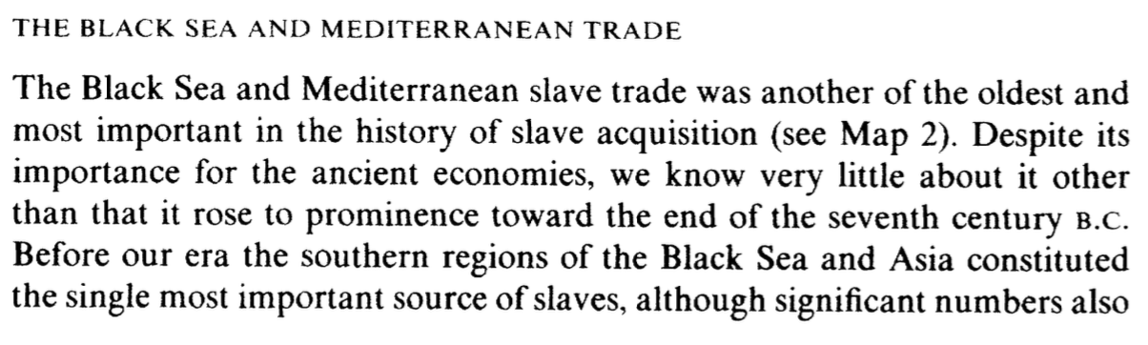

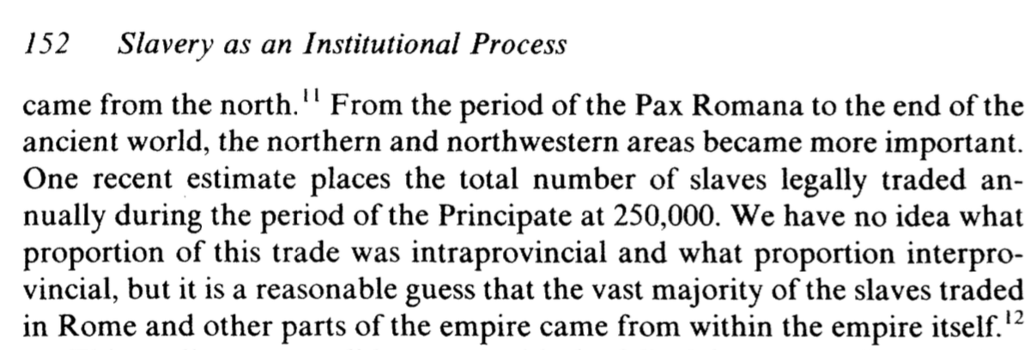

>> roman slave trade was huge!

richardson:

46

thriving mercantile class

>> While Cilician pirates largely turned to piracy because the economies in their regions of origin were poor, war-torn, Vikings turned to piracy because wanted to expand

53-54

"...slaves acquired through raiding in Ireland might have been sold in York, for example. Scandinavians played a decisive role in trade in many of the areas where they took political control. They traded not only in luxury goods, but also increasingly in ordinary bulk commodities. They also acted as middlemen between the East and the West, and after Muslim incursions in the Mediterranean closed the traditional trade routes, they opened new ones through the Baltic and Russia. Economic expansion was fueled by population increase, manufacturing growth, and new wealth – which was itself often derived from plunder and tribute. It was facilitated by Scandinavian political domination, with the fact that exchange was easy within an area under the same language and culture.

>> LIKE CILICIAN PIRATES  
 trade in luxury and common goods  
 middlemen between east and west, opened new trade routes  
>> UNLIKE CILICIAN PIRATES  
 econ expansion fueled by expansion population, political dom, manufacturing

VIKING PIRATES sustainable success of human trafficking operations due to political bases, things that come with having settlement, etc.

even if both vikings and cilicians lack particular central authority

62

vikings

"a combination of exchange and raiding which has been labelled ‘aggressive trading’, although it is not always clear whether this compromise term refers to haggling in the bazaar or to extortion at sword point. "

>> prob also cilicians could have this label